**pulse oximeter**

**Use to measure heart rate and the percentage of oxygen in the blood**

**advantage of the project**

**1- it's cost is low**

**2-easley use**

**3-easley manufacturing**

**Due to the coronavirus pandemic this project is widle use to measure the oxygen level in the blood for coronavirus pationts**

**This project is essential in hospitals and Hospital care center..**

**Project components**

**1- Arduino uno**

**2- USP caple**

**3- Resistance 46 uhm**

**4- Max 30100**

**5-Wires**

**6-Buzer**

**7- Potentialmeter**

**8-Lcd 16*2**

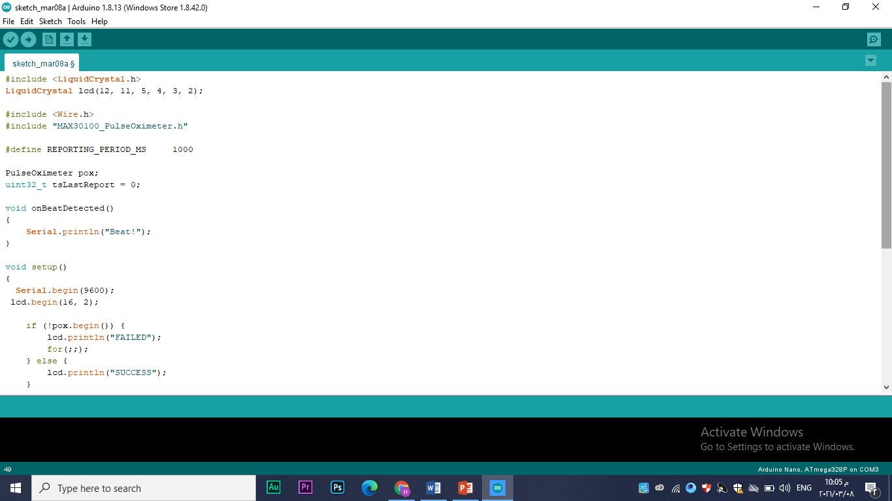**Code:**

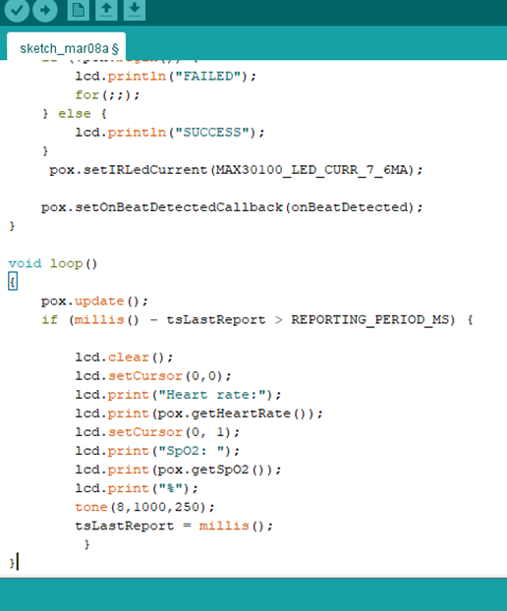

**Circuit diagram :**

